**Adult Client data**

**Demographics**

*Constant (required are those with *)*

User ID Number: generated

FirstName*

LastName*

Title

Date of Birth*

Phone number*

Email address

Gender*

Religion

Occupation

Marital Status*

Note:

1. Get next userId number

*Medical Info*

Blood group*

Genotype*

Social History

UserId

Do you smoke?

What do you smoke

How often?

Have you ever smoked ?

Do you drink Alcohol?

How Often?

HealthInformation

UserId

*Changeable*

*Vitals*

Date

Time

Weight (kg)

^BMI-calc = weight (kg) / [height (m)]2

Blood pressure - systolic/diastolic

Pulse

Blood sugar

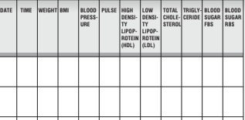

*Regular Updates*

Blood Pressure

**Medication History**

**Medication Log**

*Changing*

Date

Name of Medicine

Dose

Reason For Taking Medication

Duration

Prescribed by

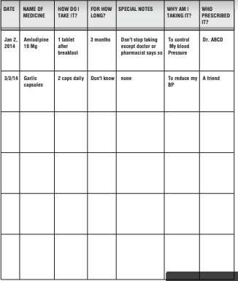

**Immunization records**

**Considerables**

Printable Records? PDF

Emailable Records? PDF / Excel

**Child Customer data**

